MLH3 Presents
A Bavarian themed social night at

Please complete this form for up to 2 people only.
Additional registrations, use additional form
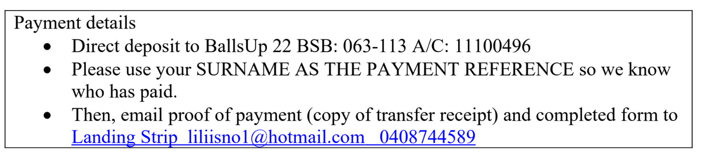
Hash Name/s
**Real Name/s
Use Surname as EFT reference
Hash Chapter
Email
Contact Phone
Total Amount paid  $.......... | EFT payment date …………..  $100 pp cut off date for registration 3rd October 2022
Seat Allocation  (would like to be seated with……) | Name/s:
Dietary Requirements

NB: MLH3 Balls Up Bank Account is being used for deposits/payments relating to this social function.
