Lakeside Haberdash
For Sale (as at August 2021)
To purchase please email Committee Contacts provided on the Website
There are also various LSH3 historical embroidered patches available.
Shorts – navy with white trim & LSH3 Logo (very comfy & light); no insert | Ladies: Large x 1;  Mens: M x 1 | $10 | 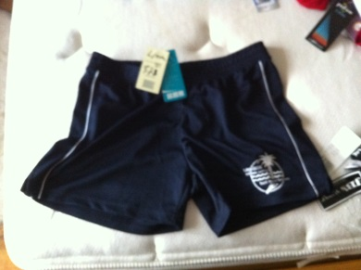
Socks – white ankle socks with LSH3 logo | Size 3-7 (x3)  Size 7-10 (x20)  Size 9-12 (x27) | $6 | 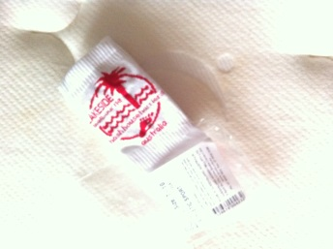
Ladies Run Singlet – Winning Spirit brand | Sold out - can order in future | $26 | 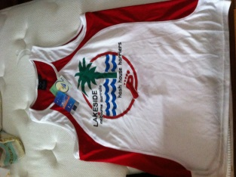
Men’s Run Singlet – Winning Spirit brand | Size XL x 2  Can order in future | $26 | 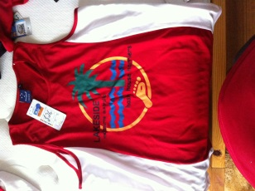
Ladies Red Polo – Podium brand with LSH3 logo  Men’s Red Polo - | Sold Out – can order in future  Size XL (x 5)  Size L (x 3) | $26  $26 | 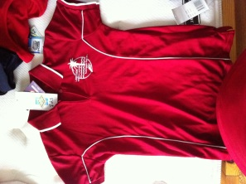
Mens or Womens Navy Polo – Podium brand with LSH3 logo | Sold out | $26 | 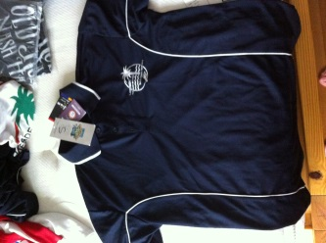
LSH3 Patches – embroidered red on white or aqua on white | Red available (only 1 left in blue) | $5 | 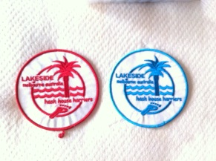
Bizcool - 35th Anniversary Shirts  V neck Women’s  Round neck Men’s | Women’s 8 (x2)  Women’s 10 (x1)  Women’s 12 (x1)  Men’s L (x1)  Men’s S (x1) | $20 | 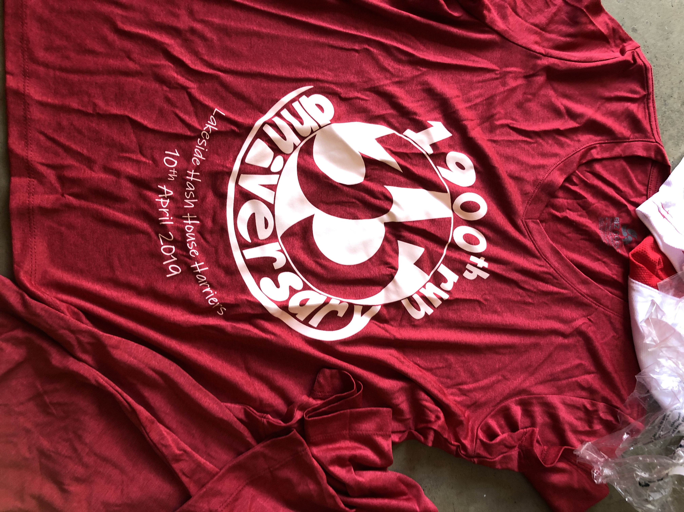
Masks  Triple layer filtration - see  https://www.flashbay.com.au/face-masks/sky-xtra  incl adjustable ear straps and nose clip and tapers chin to keep it in place | All one size | $5  (half cost price!) | 