Lakeside Run 2012 - North Port Hotel – Hare: Pythagorarse
A return from Victorian Lockdown #5 had the Lakesiders in disarray … but in true hashing spirit we found a way. We were limited to groups of 10 and masks and sitting down when in the Pub … but we prevailed.
The hare sent the pack of about 17 into the night and they initially moved toward the city. A loop and a meander past our old Graham St Drinkstop towards some splendid Port Melbourne housing estates. A staggered start had the first group of runners unsure on whether to mark checks and this caused great confusion to the walkers who actually had to check out a bit of trail… This was a good thing – they’ve had it too good for too long! The pack spread and gathered and after about an hour returned to the cold beer at the North Port.
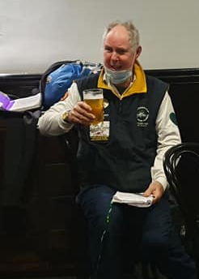
The new GM called a quick circle. Both runners and Walkers rated the run at 8 ½ under the new decimal run rating system. Visitors WAH and HORNY from Palmerston North were welcomed. Good to see Virgins Maggie and Suzie again. Some charges were laid on PRINCE and ROO DOG, amongst others. The Sergeant came up with a new take on “Pythagorarse’s theorem” POG got an award for best city day run for the last year. And heaps more happened as the night descended into nosh and beer. Some great photos from our new and prodigious Hash Flash WILD RIDER. I’ll Leave you with a PRINCE composition
So this is Lakeside
Another year has been run
Another GM has retired
And a new one just begun."

"So this is Lakeside
Bring on 2021
Theres more trail laid out there
Waiting to be run."

"So ON! ON! everybody!
And let us all cheer.
Lets make it a good one,
With plenty of beer!"
(repeat with gusto)

ON ON Pythagorarse

