
Combined Hash Bike Weekend

WANGARATTA 10 – 12 OCTOBER

Canberra Sunday Bike Hash is organising the next combined bike Hash winery weekend. The ride will in the scenic (and flat) countryside in the Wangaratta/Milawa area.

Cost
$120 which covers champers and orange refreshment stop, tastings at four wineries, lunch, gin and tonic drink stop, circle with open bucket, restaurant dinner, Sunday breakfast and an event give-away.

Event timetable
Friday 10 October
Arrive in Wangaratta and head to Pinsent Hotel in Reid Street for drinks and dinner booking at 7:00pm (at own expense).

Saturday 11 October
Breakfast in town (at own expense)
Ride - 9:30am start from the carpark of Pinsent Hotel
7:00 pm dinner at Rinaldo’s Casa Cucina Italian restaurant in Faithful Street.

Sunday 12 October
8:30 am Hash breakfast at Merriwa Park

Accommodation
Wangaratta has plenty of good accommodation options, including the Pinsent Hotel, motels and Airbnbs all central to where we will be.

Registering for the weekend
Numbers will have to be limited as the wineries have caps on the number of tasters they can accommodate. Email a completed rego form and bank transfer the fee.
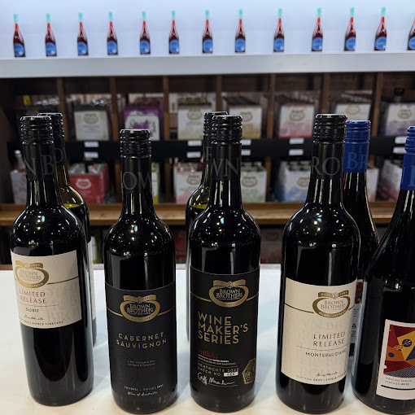
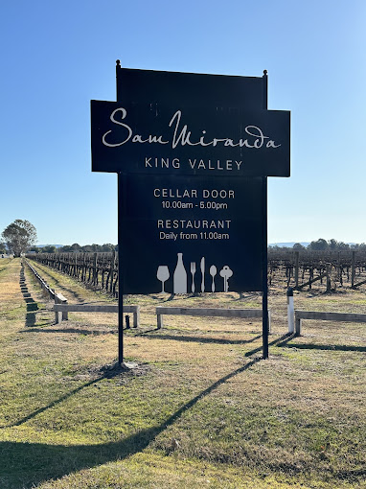
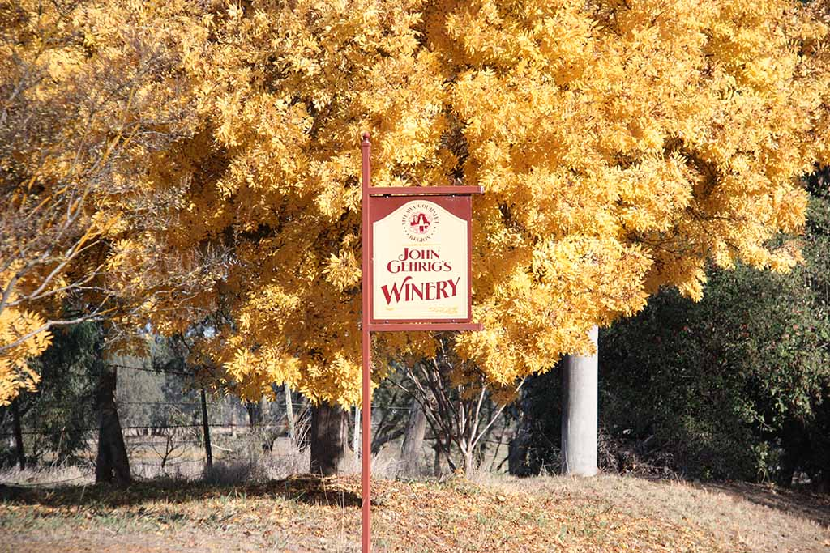



REGISTRATION

Complete your details electronically and send as an e-mail attachment to
cbrsundaybikehash@gmail.com

Hash Name/s
Real Name/s
Hash Club
Mobile/s #
E-mail/s

If you don’t want to ride, but want to take part either in getting on a non-riders’ bus, or helping out and driving around as support vehicle or lunch helper, please put a tick in the left side box and we’ll put you all in touch so you can organise yourselves.

PAYMENT DETAILS: Direct Debit - $120 per person
Bank Account Name: Pay to the Canberra Sunday Bike Hash account at
St George Bank BSB: 112908 A/C No: 414515207

Ensure your Hash Name is on the EFT reference.
- And then email Dumbell at cbrsundaybikehash@gmail.com
after Direct Debiting.
