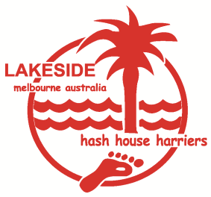
Bollywood’s Birthday Beach Run
Maximum number of 20
Due to the latest COVID restrictions, we are only allowed a maximum of 20 people in an outdoor setting (only 5 visitors in a home). So we have changed this event to be outdoors, starting from Rotary Centenary Park carpark on Ramsey Blvd, which is on the beach side of the road, between Abbott and Venus Streets, Inverloch.
Please wear your mask if you can’t keep your distance.
We’ll be on the beach so don’t forget to Slip/Slop/Slap (hat/long sleeves/sunscreen). And bring your bathers and all your beach toys so you can cool off in the lagoon and Anderson’s Inlet.

Please register below and send back to Botak Chin so he can appropriately cater for everyone (and we also abide by COVID practices).
Thank you for your understanding for this rigmorole.
From 2pm for 3pm run
$10 per person
BYO Drinks & DD Mug
Date : Saturday 20th February 2021
Rotary Centenary Park on Ramsey Blvd —
(between Abbott & Venus Streets, Inverloch)
Wear a mask when u can’t physically distance
REGISTRATION: (Just type in this word document)
Real Name/s…Cheryl Brown and David Cheeseman……………………………………………………………………….
Hash Name/s………Gargoyle and Udder……………………………………………………………………
Phone no./s …0414 716 382…………………………………………………………………………….
Please save this word document, fill in the details and then attach to an e-mail and send back to Botak Chin on iemjones@hotmail.com

Lakeside HHH Run No. 1987

